Netflix Titles File

1. Data drive

Difficulties while importing the dataset is after importing is that you have to reconnect the database schema it was challenging but manageable.

Interesting thing about the chosen dataset is that the data is real but it was never updated after 2021.

1. Data Fun

* Simple SQL queries

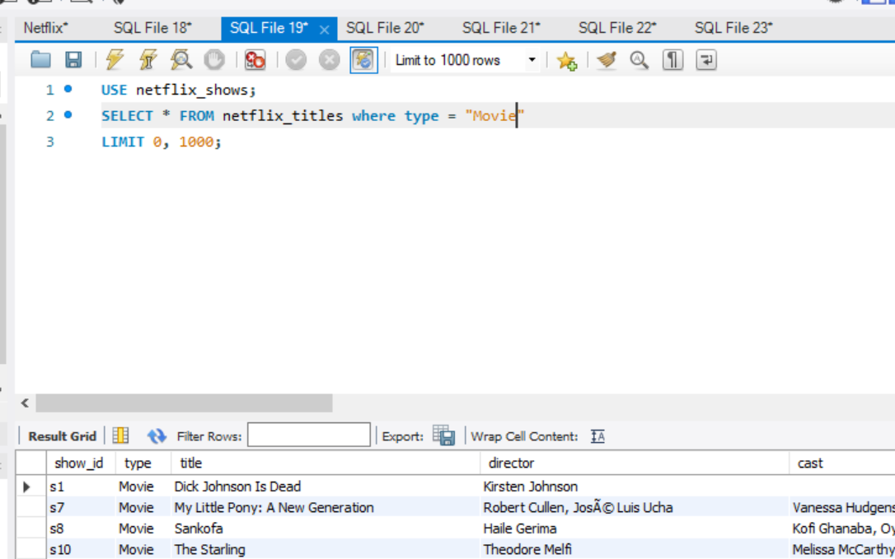

* Cool facts hidden within the data

Assuming that people from a particular country mostly watch titles released by their country, United States has the highest releases making it the country with the most viewers.

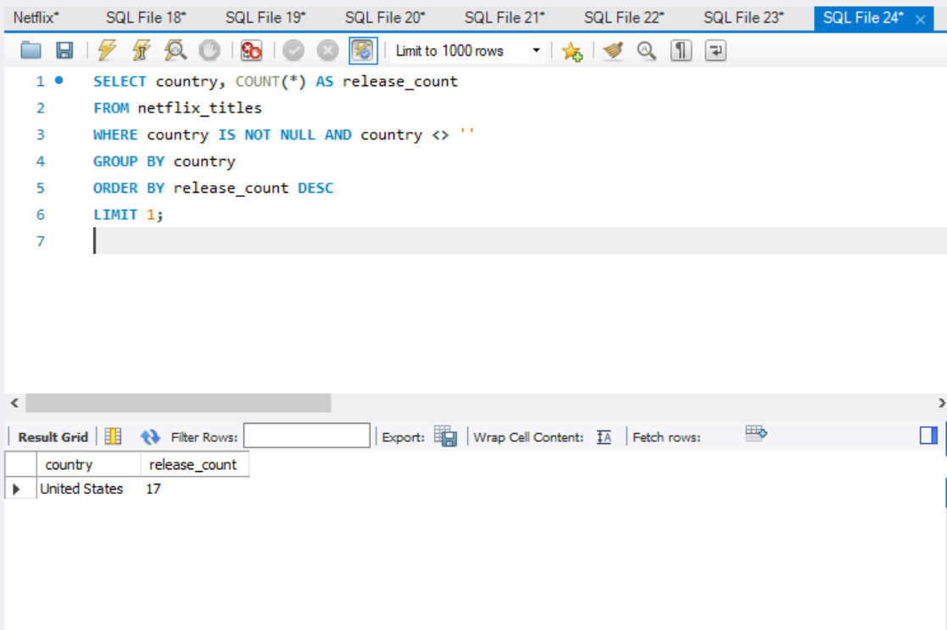

Checking Unites States releases

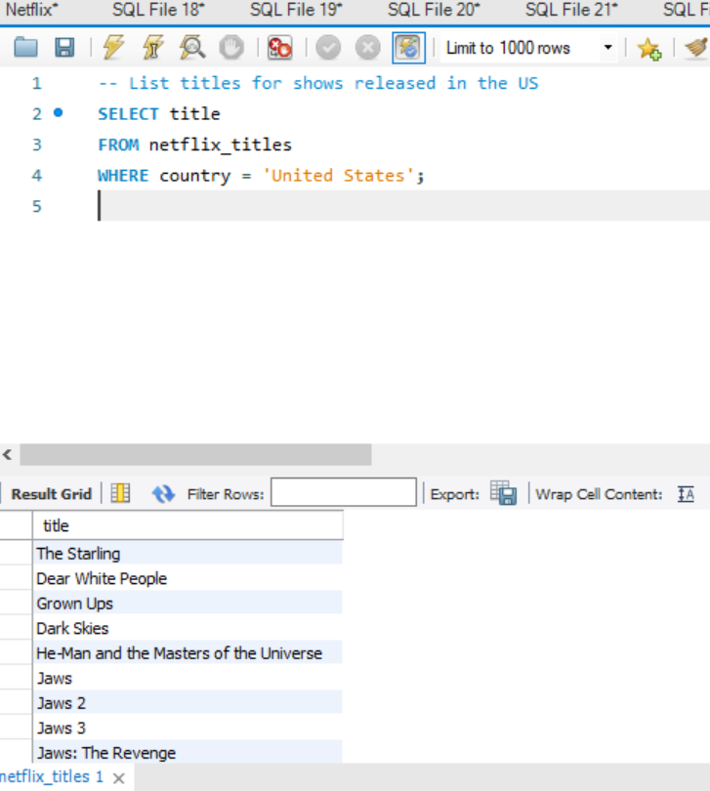

* Basic SQL queries to understand more about the data you have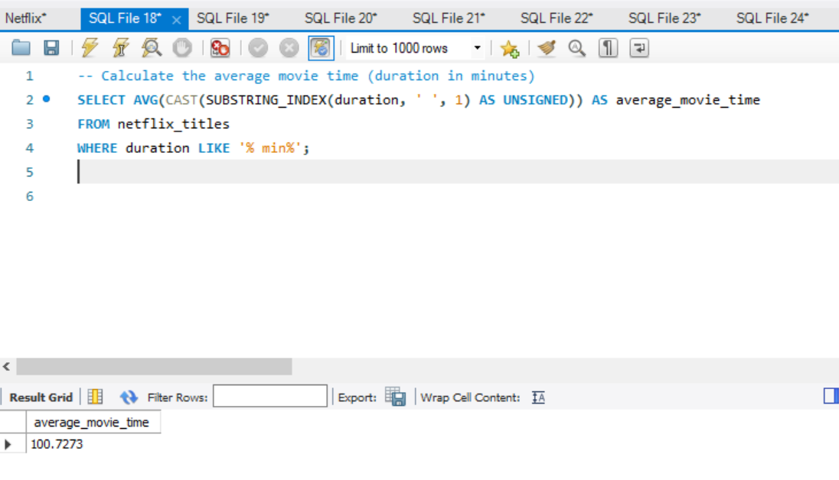

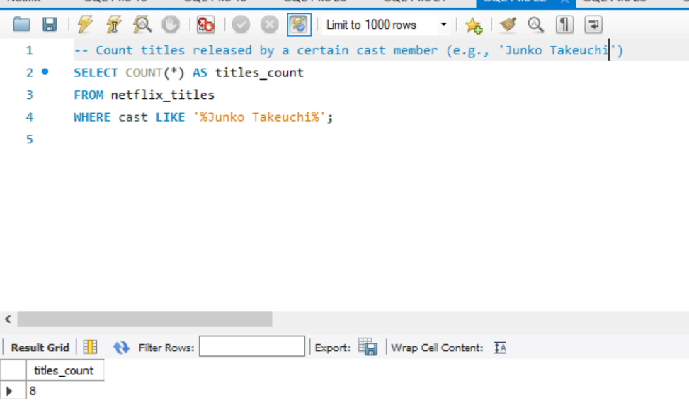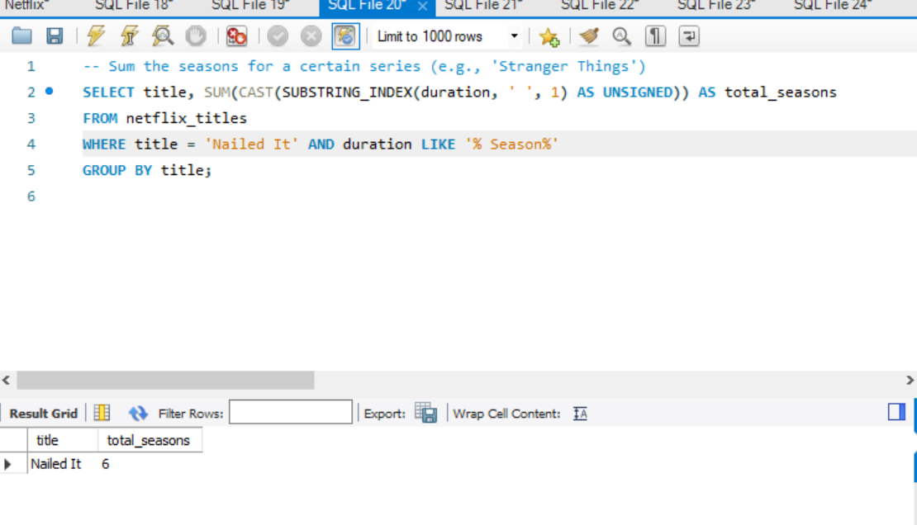

1. Ask Away

Getting the most popular TV shows in a particular state

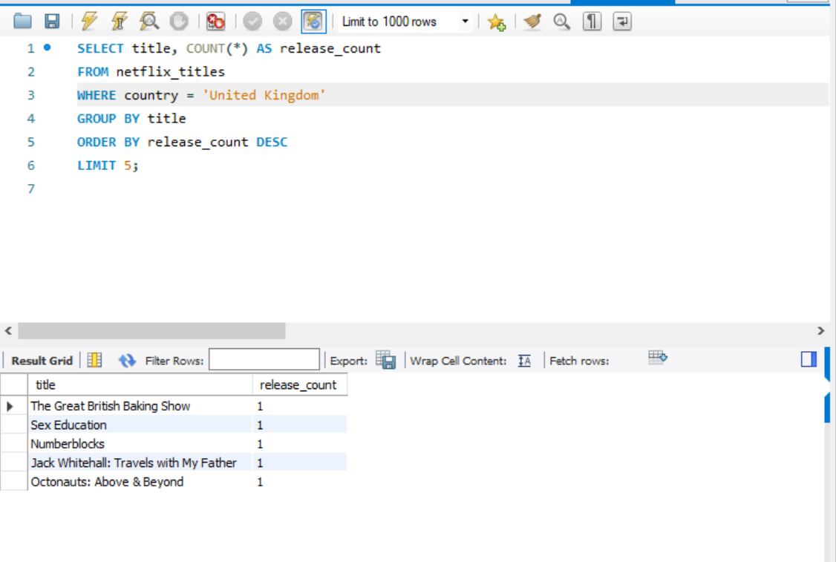

Getting a list of how frequent particular casts have appeared in descending order.

